**NOAA Ship THOMAS JEFFERSON Procedure Document**

Procedure:

**Holiday Line Planning**

Creation Date: 8-10-20

Revision Date:

Software used:

Procedure Number:

**TBD**

Approved:

**TBD**

# Overview and Scope

This is how to create a holiday plan.

# 2. Procedure Inputs and Outputs

Inputs: Holiday file from QC tools, whatever version of Caris you are using for your project (this SOP is written for 11.3).

**Either your MBES surface or a combined SSS and MBES surface that was created using survey outlines.**

Outputs: Holiday plan.

# 3. Procedure

1. Open Caris and load in your holiday finder file (.000) and surface. A bunch of black numbers should pop up where there are holidays. To make them a little bit easier to see, navigate to the properties – layers tab (usually on the right hand side) and find where it says “Soundings”. Under this option there should be a check box next to “size”. Check this and then change the size of the numbers to make them easier to see (I usually use 6 or 7). You should now see something resembling the below image.

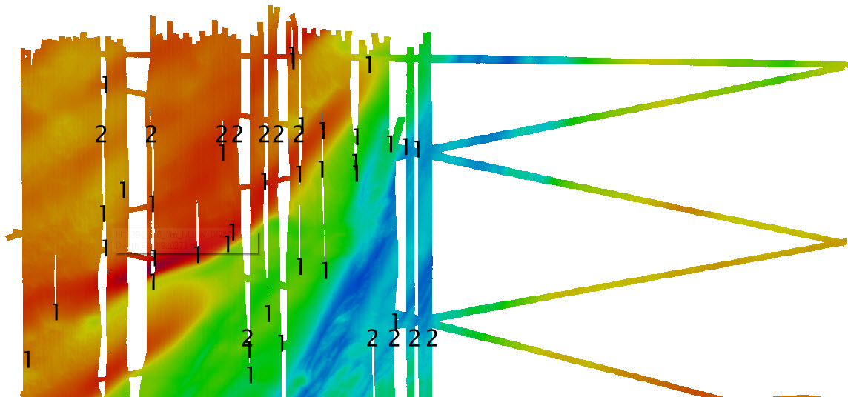

**This specific SOP is going to use the polygon method for holiday planning but using lines instead of polygons works the exact same. It is up to preference. **

1. Find the “New feature layer” button (you can also go File>New>Feature Layer). Name your feature layer whatever you’d like. However SHEETNAME_Holidays is pretty standard.
2. With this layer highlighted in the layers tab, hit the “repeat new feature” button (this will make it so that you don’t have to input attributes for each polygon you make) and then select the “area feature” option.



1. 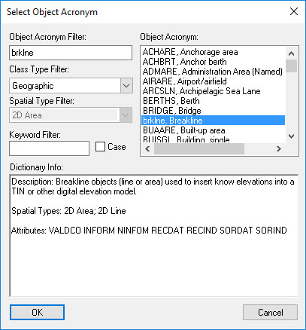A window will prompt open. You can really select any sort of object (some make more sense than others. I like to use brklne because it requires few attributes to be filled out and less work is better ☺. Hit “Okay”. Navigate to the ‘Attributes’ tab on the right hand side and fill out the “value of depth cont.”. Just put any number here it doesn’t actually matter.
2. Now you can draw your polygons. It is best to group holidays that are in a line together just for efficiencies sake but you do you.
3. Once you have the polygons created, making sure that the holidays layer is selected, hit ctrl-a. This should select all of the polygons in this layer. Without clicking on the screen navigate File>Export>Selection>S-57. Name your file whatever you’d like.

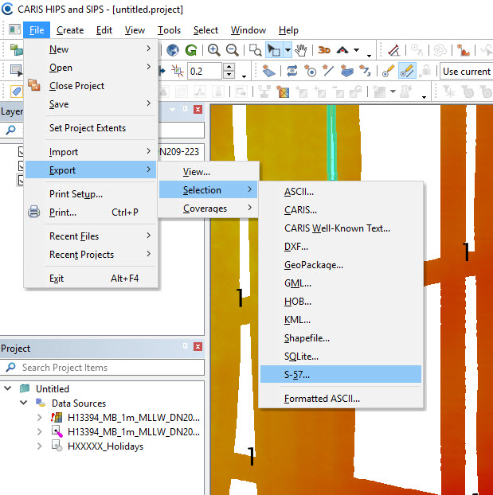

1. With your now .000 file full of polygons, open hypack. Add file and copy your holiday file into the background section. You should see your polygons over your surface now. You can either leave these the way they are and paint them in with multibeam or you can create lines over them in hypack (see line planning SOP on K drive). It is up to the sheet manager on how they would like to tackle the holidays. Use your best judgement.

CONGRATS YOU DID IT.

# 4. References

N/A